1. 1st-Level and 2nd-Level Caching is ID based.
2. 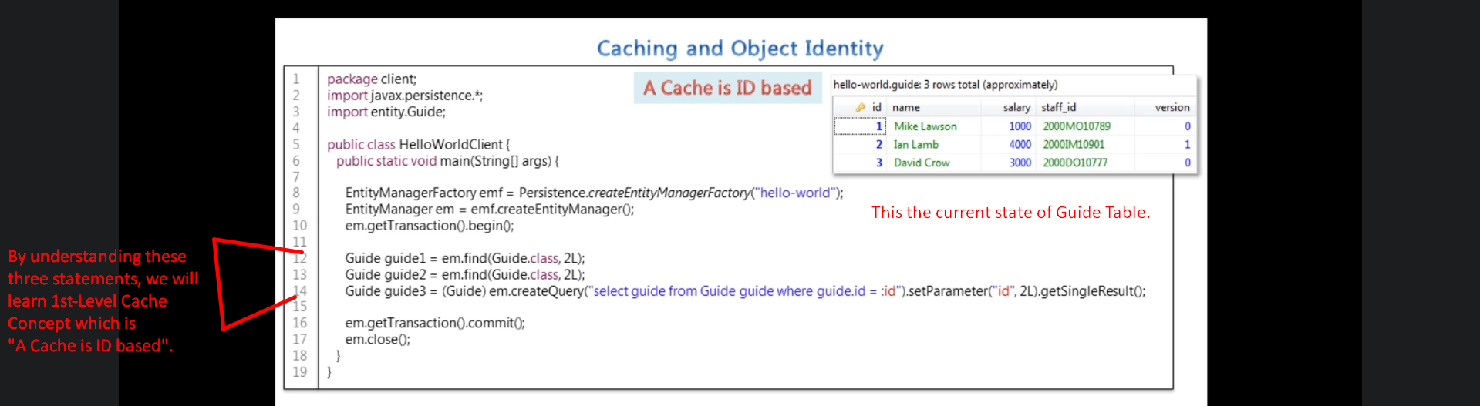
3. 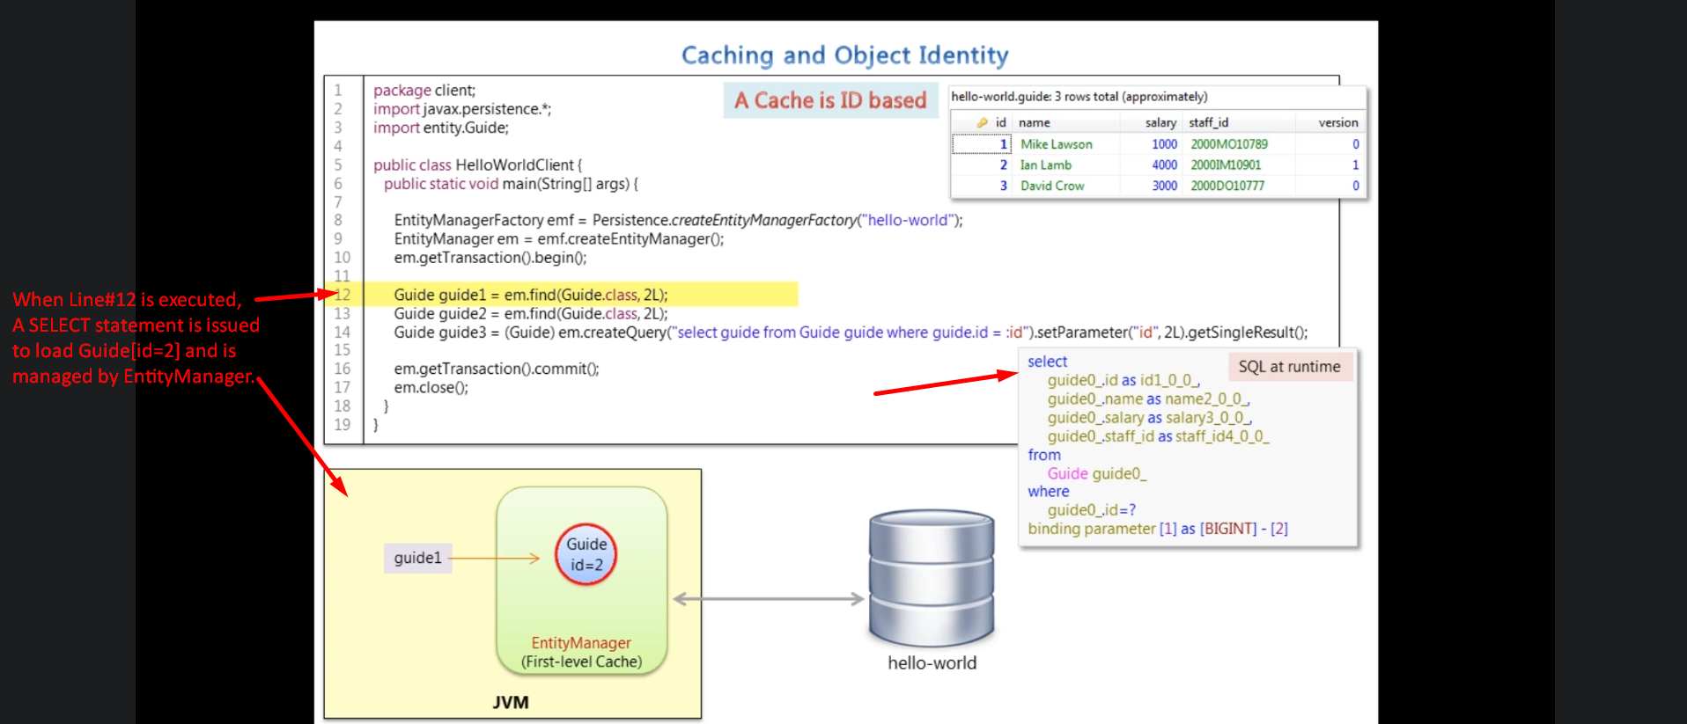
4. 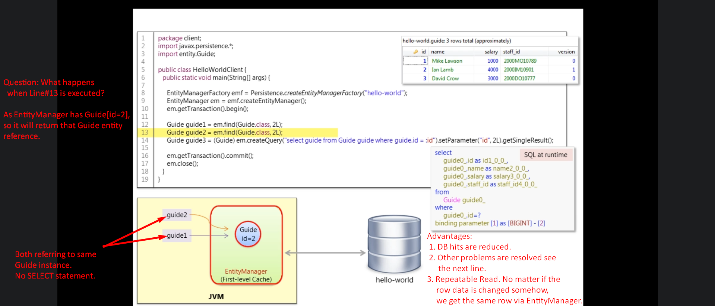
5. 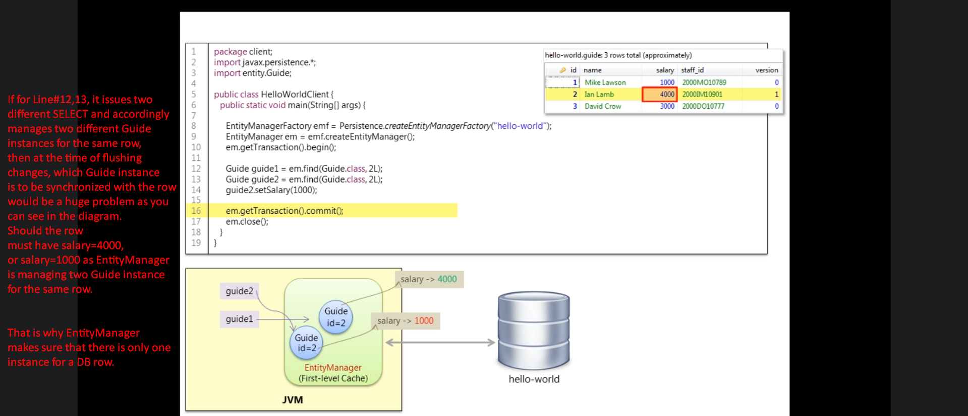
6. Why Hibernate is issue a new SELECT statement this time when executing the Line#14.
   1. Because Cache is ID based.
   2. What does it mean really?

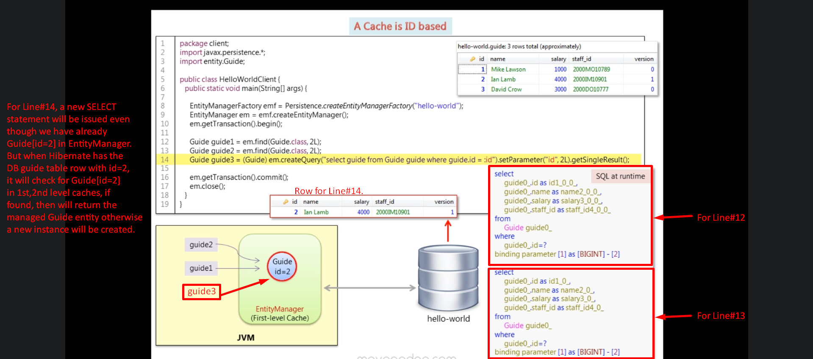

1. 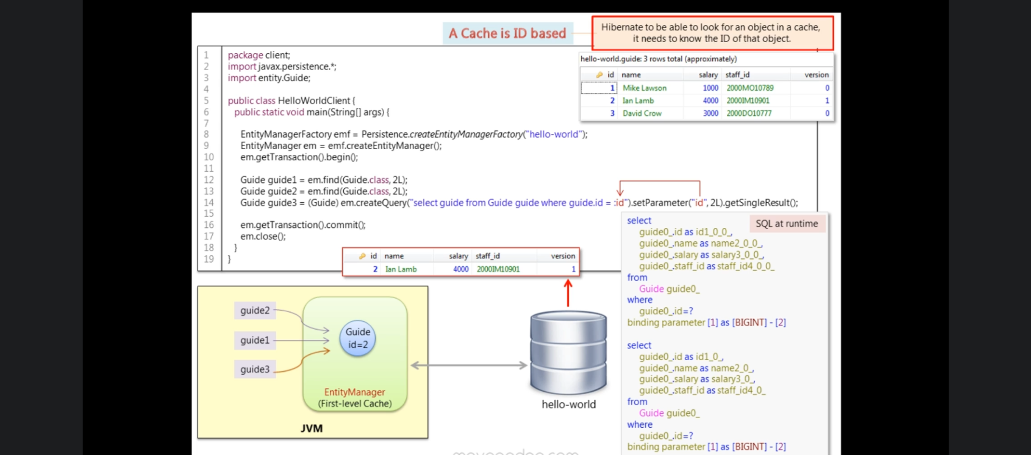
2. 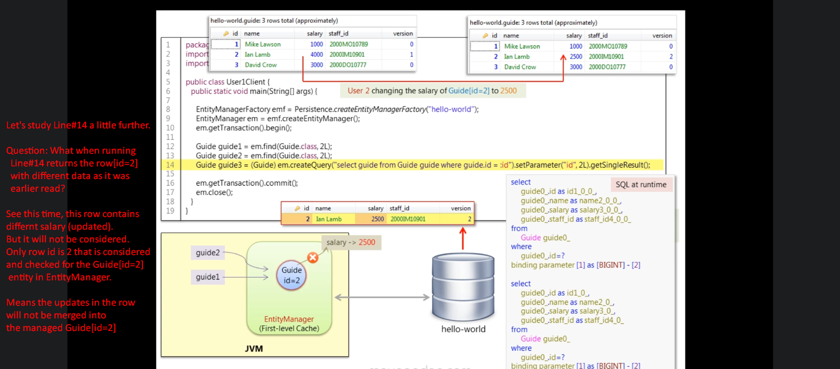**NOTE**: Note in the above scenario, when executing Line#14, the SELECT statement is issued but when hibernate receives the row, it checks whether the Guide[id=2] entity is present in the EntityManager as the row id =2. If it is present, it will discard the row and returns that entity reference and this is happening here.  
   See, No matter what isolation level is set for the DBMS but 1st-Level Cache is providing REPEATABLE_READ isolation internally.
3. **Advantages for First-Level Cache**:
   1. Internally, it provides REPEATABLE_READ isolation level no matter what isolation level is set for DBMS.
   2. Reduces the # of DB hits because if entity for the row is present in 1st-Level cache, it will return that row.
   3. Only one entity is to be managed for any row.